**Tutorial documentation**

**1. Learning objectives**

In this course, we mainly learn to use STM32F103RCT6 to drive building block motors.

**2. Prepare before class**

The hardware required is STM32F103RCT6 development board, building block motor, motor drive module, and DuPont line.

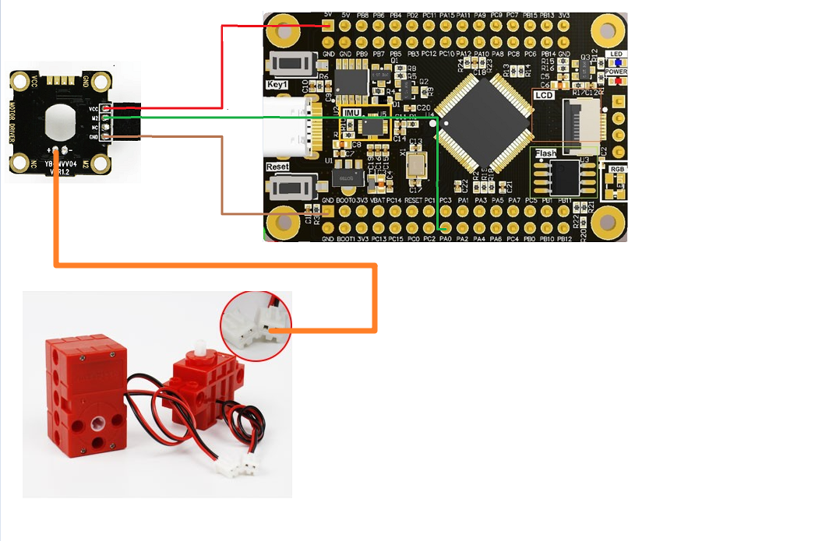

|  |  |
| --- | --- |
| Motor drive module module | STM32F103RCT6 |
| VCC | 5V |
| GND | GND |
| M2 | PA0 |

The building block motor is connected to the motor interface of the motor drive module.

1. **Program**

Initialize the pin as well as the timer.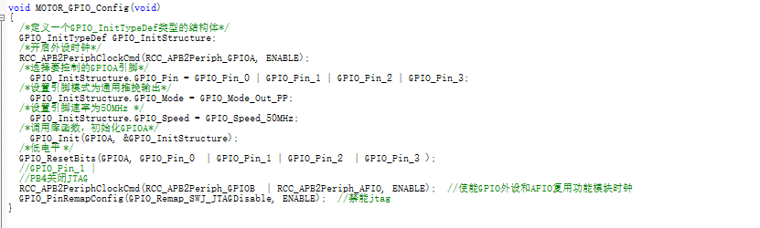

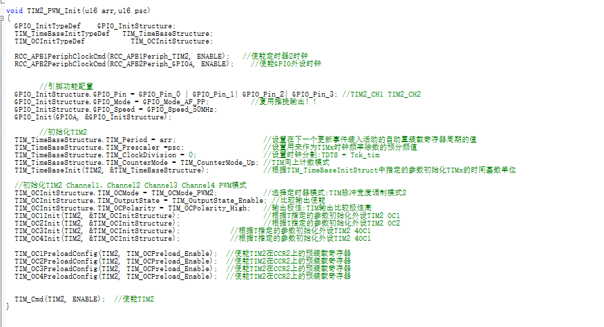

The output voltage is controlled by duty cycle.

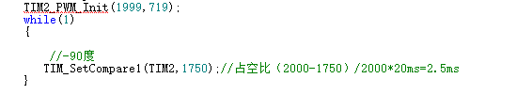

1. **Experimental phenomenon**

After the program is downloaded, we can see that the motor rotates slowly, and we can control the speed of motor rotation by changing the size of the duty cycle.